«Event»

«Place» Place

«Name»

Presented at Region IX SAFECON, this 1st day of November, 2008
Hosted by Embry-Riddle Aeronautical University
Daytona Beach, Florida

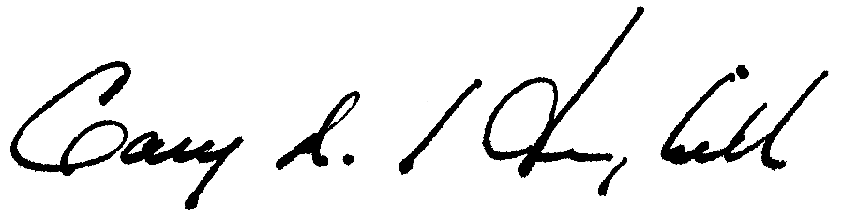

_______________________________________________ | _______________________________________________
Gary A. Hemphill  NIFA Executive Director | Vicki Lynn Sherman..  Chief Judge..

